Project Title
(GenoMatch: Discovering Local Similarity in Biological Sequences)
Project Report submitted for the partial fulfilment of grade for the course

Data Structures and Algorithms -3 (25CS2103E)
in

A.Y. 2026-2027

Submitted by
M.Nishant – Roll.No.2520030323
M.Ram Ratan – Roll.No. 2520030291
Ashwanth Reddy – Roll.No. 2520030081

Team Number: 12
Section: 4

Under the guidance of

Professor Yamini Devi


<<Designation, Department>>
Hyderabad-500090, Telangana, India.

K L (Deemed to be) University
DEPARTMENT OF COMPUTER SCIENCE ENGINEERING / COMPUTER SCIENCE AND INFORMATION TECHNOLOGY/ARTIFICIAL INTELLIGENCE & DATA SCIENCE



DECLARATION

The Mini Project Report entitled “Project Title” is a record of Bonafide work of Name – Roll.No., Name – Roll.No., Name – Roll.No. , Name – Roll.No. submitted in partial fulfillment for the award of B. Tech in Computer Science and Engineering/Computer Science and Information Technology/ Artifical Intelligence & data Science to the K L University. The results embodied in this report have not been copied from any other departments/University/Institute.

M.Nishant – Roll.No.2520030323
M.Ram Ratan – Roll.No. 2520030291
Ashwanth Reddy – Roll.No. 2520030081

K L (Deemed to be) University
DEPARTMENT OF COMPUTER SCIENCE ENGINEERING / COMPUTER SCIENCE AND INFORMATION TECHNOLOGY
CERTIFICATE

This is to certify that the mini project based report entitled “Project Title” is a bonafide work done and submitted by Name – Roll.No., Name – Roll.No., Name – Roll.No., Name – Roll.No. in partial fulfillment of the requirements for the award of the degree of BACHELOR OF TECHNOLOGY in Department of Computer Science Engineering/ Computer Science and Information Technology/Artificial Intelligence & Data Science, K L (Deemed to be University), during the academic year 2026-2027.

Signature of the Supervisor

Signature of the HOD Signature of the External Examiner

ACKNOWLEDGEMENT

The success in this project would not have been possible but for the timely help and guidance rendered by many people. Our wish to express my sincere thanks to all those who has assisted us in one way or the other for the completion of my project.

Our greatest appreciation to my guide, <<Guide Name>>, <<Designation>>, <Department>> which cannot be expressed in words for his/her tremendous support, encouragement and guidance for this project.

We express our gratitude to Dr. P.Venkateshwar Rao (CSE)/Dr. Khaja Shareef (CSIT)/ Dr. Sreenath Itikela (AI&DS), Head of the Department for Computer Science Engineering/ Department for Computer Science and Information Technology/Department of Artificial Intelligence and Data Science for providing us with adequate facilities, ways and means by which we are able to complete this project-based Lab.

We thank all the members of teaching and non-teaching staff members, and also who have assisted me directly or indirectly for successful completion of this project. Finally, I sincerely thank my parents, friends and classmates for their kind help and cooperation during my work.

M.Nishant –Roll.No.2520030323
M.Ram Ratan – Roll.No. 2520030291
Ashwanth Reddy – Roll.No. 2520030081

TABLE OF CONTENTS

S.No. | Contents | Page no.
1. | Abstract
2. | Introduction
3. | Literature survey
4. | Problem Statement and Objectives
5. | Hardware and Software requirements
6. | Implementation
7. | Results & Discussion
8. | Conclusion & Future Scope
9. | References

1.ABSTRACT
Abstract
This project presents a sequence alignment tool that implements the Smith–Waterman algorithm to identify optimal local alignments between two biological sequences, such as DNA or protein strings. Unlike global alignment methods, the tool focuses on detecting highly similar subsequences embedded within larger sequences, making it well-suited for genomic similarity analysis. The system employs dynamic programming to construct a scoring matrix based on configurable parameters, including match, mismatch, and gap penalty values, and performs traceback to extract the highest-scoring local alignment. The application visualizes the aligned subsequences alongside their computed alignment score. By allowing users to adjust scoring parameters, the tool supports experimentation with different alignment sensitivities suited to varied biological contexts. This project demonstrates the practical application of dynamic programming in bioinformatics.
Team Name: GenoMatch: Discovering Local Similarity in Biological Sequences
Team Members:
M.Nishant – Roll.No.2520030323
M.Ram Ratan – Roll.No. 2520030291
Ashwanth Reddy – Roll.No. 2520030081

- INTRODUCTION

Sequence alignment is a fundamental technique in bioinformatics for finding regions of similarity between DNA, RNA or protein sequences. Such similarity often points to functional, structural or evolutionary relationships. Alignment methods fall into two types: global alignment, which aligns two sequences end to end, and local alignment, which finds only the best matching regions. Local alignment is more useful when sequences are similar in parts, such as a conserved gene or protein domain, and different elsewhere.
The Smith–Waterman algorithm (1981) is the classical dynamic programming method for optimal local alignment. It builds a scoring matrix in which every cell holds the best score of an alignment ending at that position, and any negative score is reset to zero so that a new alignment can begin anywhere. The alignment is recovered by tracing back from the highest-scoring cell until a zero is reached.
This project implements the algorithm in Java as an interactive desktop tool, SeqAlign, with configurable match, mismatch and gap scores and visual output of the aligned subsequences and the scoring matrix

- LITERATURE SURVEY
1. Enhancing Sequence Alignment in Bioinformatics (GitHub, iabhiroop). This project implements the Smith–Waterman algorithm for local alignment of DNA or protein sequences. The user enters two sequences and the match and mismatch scores, and the program builds the alignment matrix, performs the traceback and displays the result with a traceback map. It covers the core algorithm well but has no gap-penalty setting, no comparison with other algorithms, and no performance analysis, which our project adds.
2. smith-waterman-alignment (GitHub, mcclowes). This repository implements Smith–Waterman in Python, reading pairs of sequences from an input file and locally aligning each pair. A second task aligns several sequences against a template and builds a merged sequence from the local alignments. It works from the command line only and has no graphical output, whereas our tool provides an interactive interface with visualization.
3. HelixMatch (GitHub, Amna2327). HelixMatch uses the Smith–Waterman algorithm in JavaScript to align a user’s DNA sequence against a reference library of known pathogenic mutations from ClinVar and NCBI GenBank. It shows a practical genomics use of local alignment for pre-screening genetic diseases. It is built for one specific use case, while our project is a general-purpose tool with configurable scoring.
4. Smith-Waterman Implementation in Python (GitHub Gist, radaniba). This is a Python script for local alignment of nucleotide sequences with fixed scores (match +2, mismatch -1, gap -1) and unit tests. It prints the alignment string and counts, and it is widely reused as a teaching example. Its scores are hard-coded and its output is text only, which are the limits our configurable, visual tool improves on.
5. smith_waterman_spc (GitHub, whbrewer). This project is a modified fork of the Python gist above, adapted to run on the SPC cloud platform. It shows that Smith–Waterman can be packaged and run as a service in the cloud. Like the original, it focuses on running the algorithm and not on interactive visualization or scoring experiments.
6. TheAlgorithms/Rust: Smith-Waterman module. This is an open-source Rust implementation of Smith–Waterman in a collection of dynamic programming algorithms. It uses the reset-to-zero rule that makes the alignment local and is documented as a learning reference. It is a library module with no user interface, so users cannot enter sequences or view results visually.
7. EMBOSS Water (EMBL-EBI). EMBOSS Water is a widely used web and command-line tool that applies the Smith–Waterman algorithm to two sequences. It supports substitution matrices such as EBLOSUM62 and EDNAFULL with gap-open and gap-extend penalties. It is accurate and professional, but it returns plain text only and does not explain the scoring matrix or traceback, which our visual tool does for learning.
8. Parasail (GitHub, Jeff Daily). Parasail is a high-performance C library with SIMD implementations of Smith–Waterman (local), Needleman–Wunsch (global) and semi-global alignment. It was shown to be faster than several earlier implementations and, for many score matrices, faster than BLAST. It targets speed for large-scale use, while our project targets clarity, visualization and teaching.
9. NCBI BLAST. BLAST is the most widely used sequence search tool and is a heuristic approximation of Smith–Waterman, designed to search huge databases quickly. It gives up some sensitivity for speed and can miss alignments that the exact algorithm finds. This is why our project uses the exact Smith–Waterman method for accurate local alignment of individual sequence pairs.
Summary: Existing work either implements the algorithm without visualization or configurable scoring (1–6), gives accurate but text-only output (7), optimizes for speed (8), or trades exactness for speed (9). Our project combines exact Smith–Waterman alignment, configurable scoring, heatmap and alignment visualization, and a comparison with global alignment and KMP in one interactive Java tool.

- Problem Statement and Objectives

Problem statement: Given two biological sequences, identify the most similar local subsequences between them, compute the optimal local alignment score, and present the result visually, while allowing the scoring rules to be configured by the user.
Objectives:
- Implement the Smith–Waterman dynamic programming algorithm from scratch.
- Support DNA and protein sequences with input validation.
- Provide configurable match, mismatch and gap scoring parameters.
- Perform traceback to extract the optimal local alignment and its positions in both sequences.
- Visualize the aligned subsequences and the scoring matrix with the traceback path.
- Compare the approach with global alignment (Needleman–Wunsch) and exact matching (KMP), and measure runtime growth.
- Validate the tool with test cases and real genomic and protein datasets.

5.HARDWARE AND SOFTWARE REQUIREMENTS
Hardware Requirements:
- Processor: Intel Core i3 or above
- RAM: 4 GB minimum (8 GB recommended)
- Storage: 200 MB free space
- Display: 1366 × 768 or higher
Software Requirements:
- Operating system: Windows 10/11, Linux or macOS
- Language: Java (JDK 17 or above)
- GUI and graphics: Java Swing and Java2D (standard library, no external jars)
- IDE: Visual Studio Code with Extension Pack for Java
- Datasets: NCBI GenBank (SARS-CoV-2 reference NC_045512.2) and UniProt protein sequences

- IMPLEMENTATION

Module 1: Scoring Parameters (ScoringConfig.java)
Stores the configurable match, mismatch and gap values and validates them.
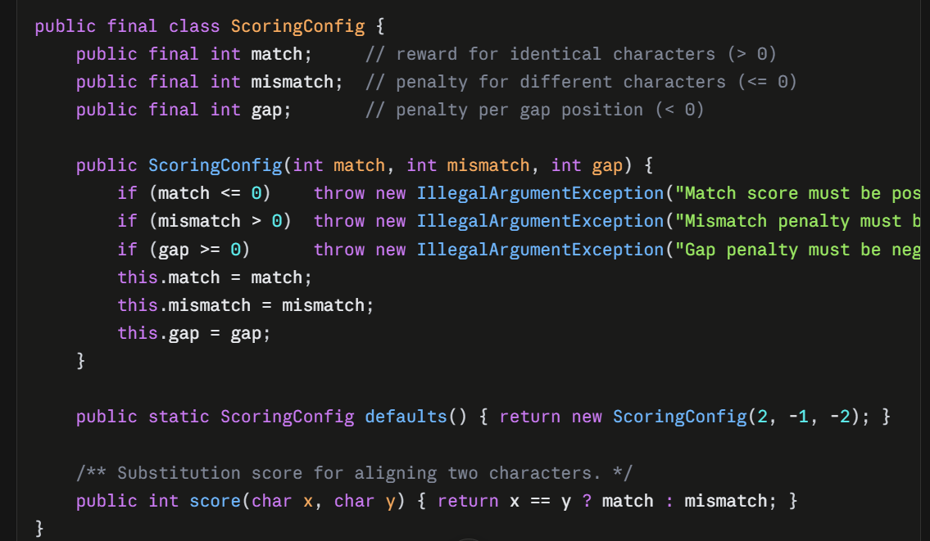

Module 2: Input Cleaning and Validation (SequenceUtil.java)
Removes FASTA headers, spaces and digits, converts to upper case, and rejects invalid characters.
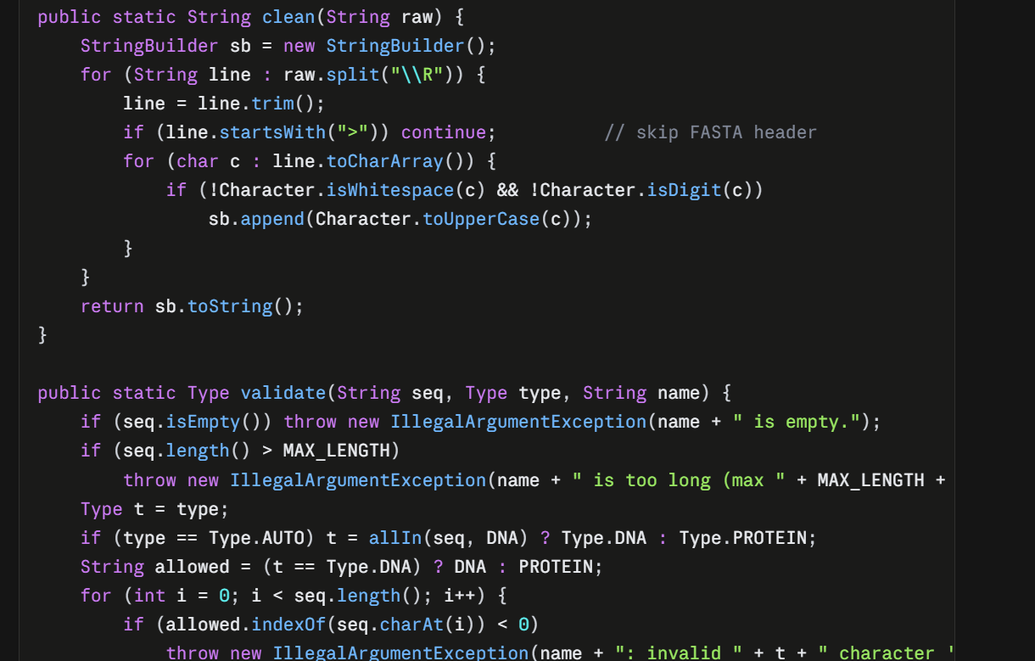

- RESULTS & DISCUSSION
The tool correctly computes optimal local alignments. On the sample DNA pair it reported a score of 50 with the aligned region at positions 9–41 in Sequence A and 6–40 in Sequence B (35 columns: 29 matches, 4 mismatches, 2 gaps, 82.9% identity).
The textbook example (TGTTACGG vs GGTTGACTA, match +3, mismatch −3, gap −2) gave the expected score of 13 with the alignment GTT-AC / GTTGAC.
All 27 test checks passed, covering identical sequences, no similarity, partial overlap, gaps, protein sequences, symmetry of the score, and input validation.
Changing the scoring parameters changed the alignment as expected. A harsher gap penalty (−10) removed the gap and shortened the alignment to GTT (score 9).
The benchmark showed runtime growing roughly quadratically with sequence length for Smith–Waterman and Needleman–Wunsch, while KMP stayed almost flat, matching the O(m×n) versus O(m+n) analysis.
(Insert here: screenshots of the Alignment tab, the Heatmap tab and the Benchmark chart, plus the dataset result from your NCBI/UniProt run.)

8.CONCLUSION & FUTURE SCOPE
This project implemented the Smith–Waterman algorithm to find optimal local alignments between biological sequences. The tool detects conserved regions even when the rest of the sequences differ, supports configurable scoring, and presents the result through an aligned-sequence view and a scoring-matrix heatmap. Testing confirmed correct results, and the comparison with global alignment and KMP showed why local dynamic programming is the right strategy for this problem class. The project demonstrates how classical algorithmic techniques apply directly to genomic similarity analysis. Affine gap penalties (separate gap-open and gap-extend costs) for more realistic scoring.
BLOSUM and PAM substitution matrices for protein alignment.
Loading FASTA files directly and handling longer sequences with a space-efficient (Hirschberg) version.
Multiple sequence alignment and database search.
Parallel or GPU acceleration for large genomic data.
A web-based version for easier sharing.

- REFERENCES

- S. B. Needleman and C. D. Wunsch, “A general method applicable to the search for similarities in the amino acid sequence of two proteins,” J. Mol. Biol., 1970.
- T. F. Smith and M. S. Waterman, “Identification of common molecular subsequences,” J. Mol. Biol., 1981.
- S. F. Altschul et al., “Basic local alignment search tool,” J. Mol. Biol., 1990.
- W. R. Pearson and D. J. Lipman, “Improved tools for biological sequence comparison,” PNAS, 1988.
- O. Gotoh, “An improved algorithm for matching biological sequences,” J. Mol. Biol., 1982.
- D. S. Hirschberg, “A linear space algorithm for computing maximal common subsequences,” Commun. ACM, 1975.

